DBMS WEEK 4
TOPIC: JOINS AND SET OPERATIONS
STEP 1: CREATE TABLES
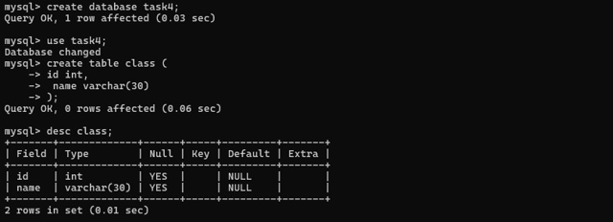
STEP 2: INSERT DATA
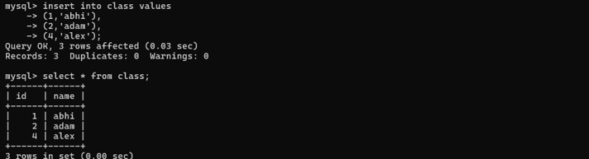
QUESTION :1 - CROSS JOIN
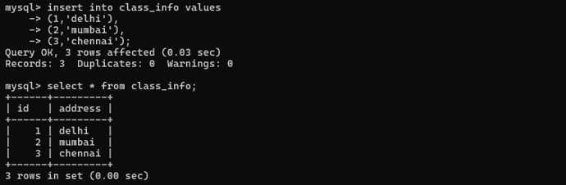
PART 2: INNER JOIN
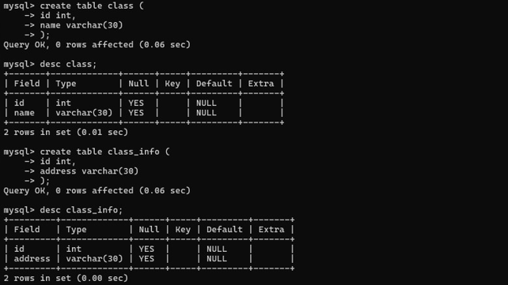
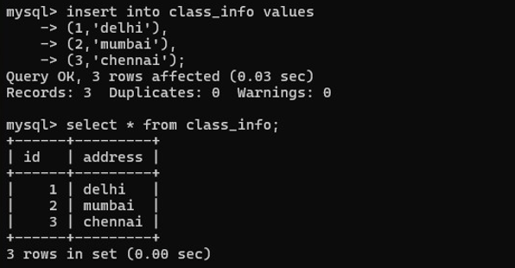
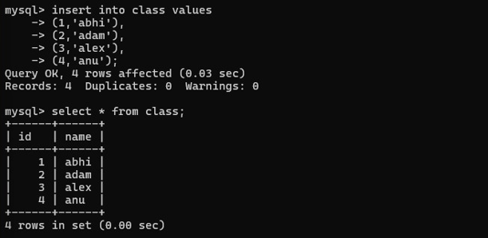

QUESTION :2 - INNER JOIN
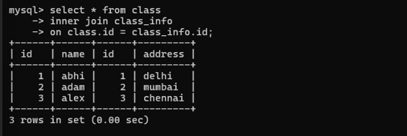
QUESTION :3 - INNER JOIN
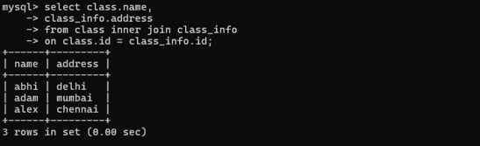
PART 3: NATURAL JOIN
QUESTION: 4 - NATURAL JOIN
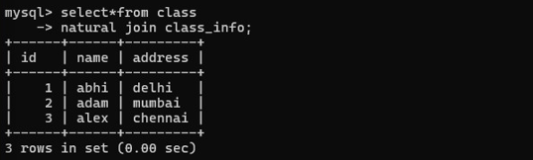
PART 4: LEFT OUTER JOIN
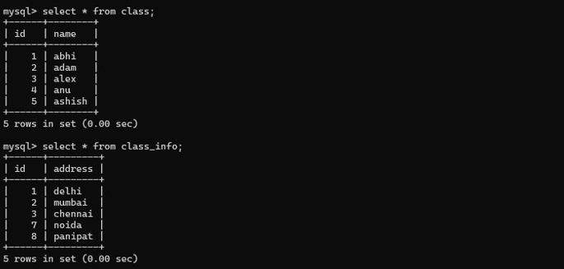

QUESTION :5 - LEFT JOIN
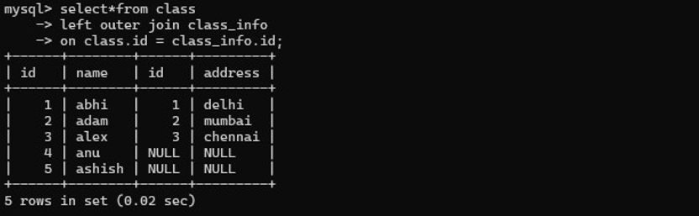
QUESTION :6 - LEFT JOIN
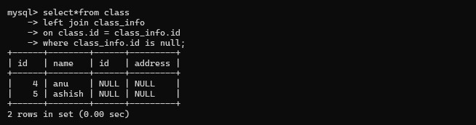
PART 5: RIGHT OUTER JOIN
QUESTION :7 - RIGHT JOIN
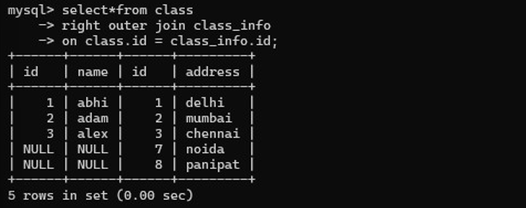
QUESTION :8 - RIGHT JOIN
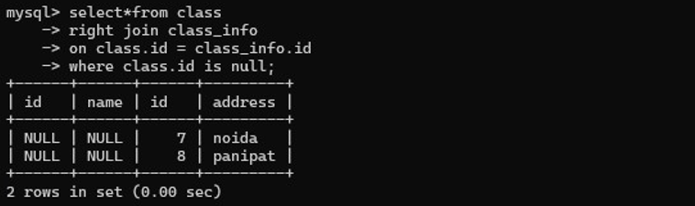

PART 6: FULL OUTER JOIN
QUESTION :9 - FULL OUTER JOIN
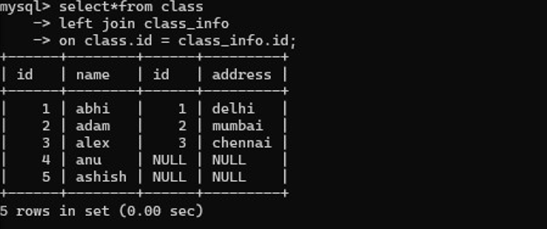
QUESTION :10 - FULL OUTER JOIN
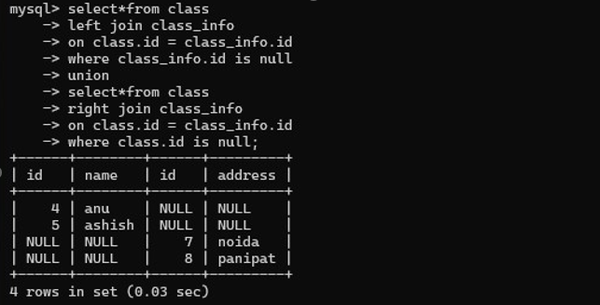
PART 7: UNION
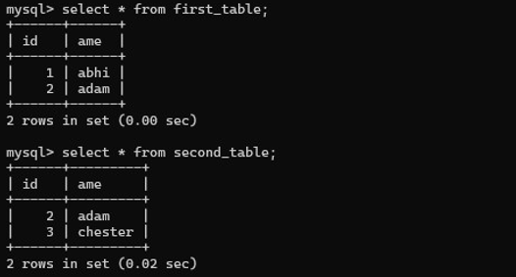
QUESTION :11 – UNION
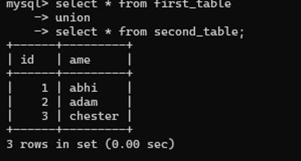

QUESTION :12 – UNION
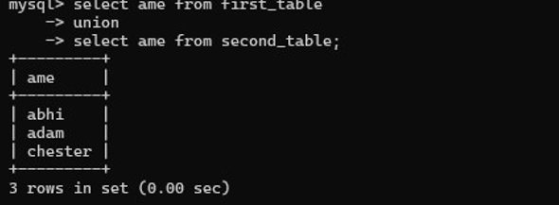
PART 8: UNION ALL
QUESTION :13 - UNION ALL
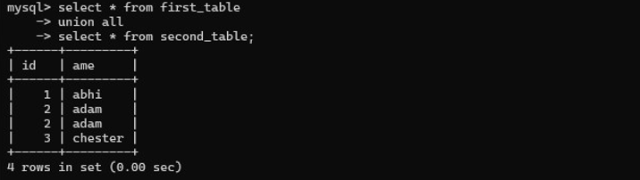
QUESTION :14 - UNION ALL
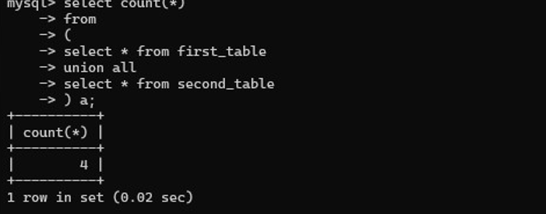
PART 9: INTERSECT
QUESTION :15 – INTERSECT
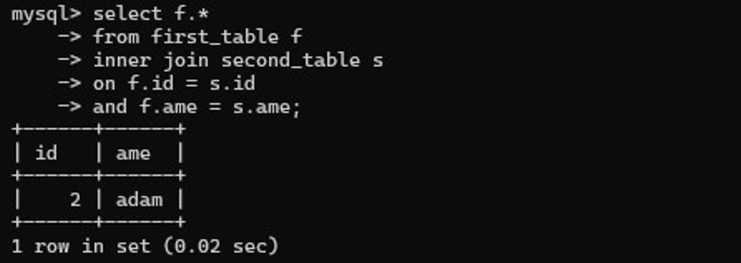

QUESTION :16 – INTERSECT
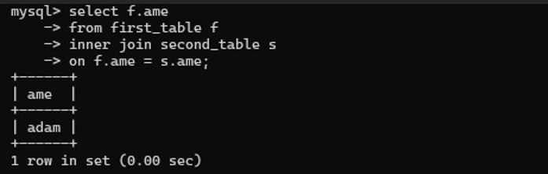
PART 10: MINUS
QUESTION :17 – MINUS
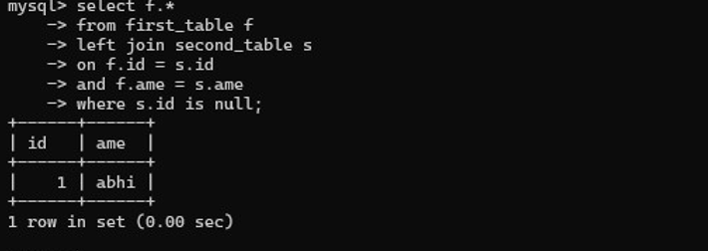
QUESTION :18 – MINUS
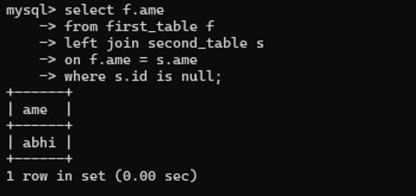
ADVANCED INTERVIEW QUESTIONS
QUESTION 19
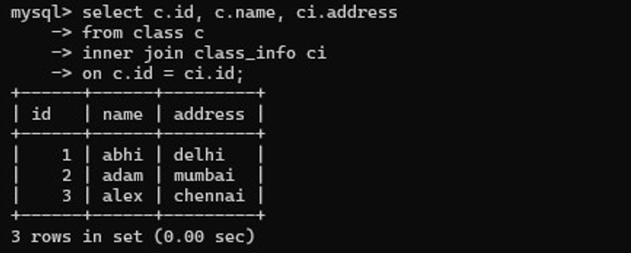
QUESTION 20
